UA Sept Storefront AB test result Update as of 2017-09-28 1:45 AM:

As of this Morning, 14 days into the test, the Test storefront with Banners is generating higher Revenue per Visitor compared to the Control storefront,

1. The conversion rate of the Test Storefront is **+5%** higher than that of the Control Storefront
2. The ATS of the Test Storefront is **+9%** higher than that of the Control Storefront
3. All in all, the Test Storefront is giving us a **+12%** lift in Revenue per Visitor
4. So far, ATS nor Conversion rate reaches the significance threshold

You can find the report here, <https://data.points.com/#/views/United_Sept2017_StorefrontTest/Summary?:iid=1>

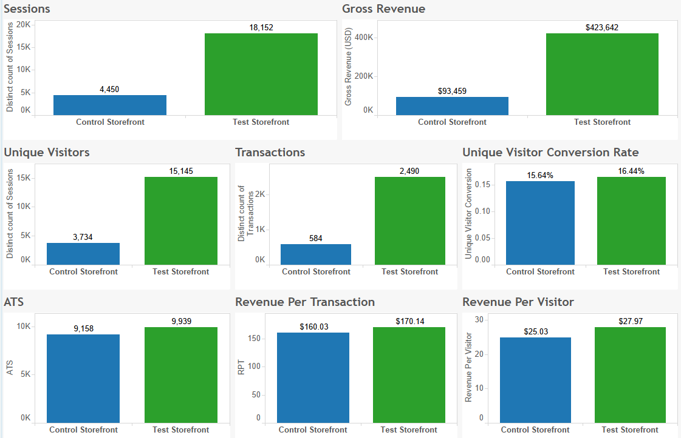

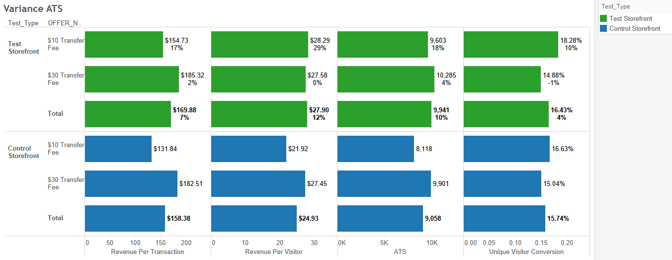

* If we further break down the Test and Control storefront by the transfer fee test offers, it’s obvious that only the $10 Transfer fee offer showed us the advantage of the Test Storefront. With the $10 Transfer Fee offer the Test Storefront generated 10% higher conversion rate, 18% higher ATS, and 29% more revenue per visitor than the Control Storefront. On the other hand, the Test Storefront performed almost the same as the Control Storefront with the $30 Fee offer.
* However, in the other test of the Transfer Fee, the $30 Transfer Fee offer generated 2% higher Revenue per Visitor than the $10 Transfer fee. So if we ended up deciding to keep the $30 Transfer Fee offer, there’s no point of using the new-designed storefront because it did not show any advantage in the Storefront Test.
* So what if we choose to use the $10 Transfer Fee and Test storefront? Compared to the current state, which is $30 Transfer Fee and Control Storefront, the combination mentioned above generated significantly higher conversion rate (22%), -3% lower ATS, and 3% higher Revenue per Visitor. Although the increase in Conversion Rate is significant, and the decrease in ATS is not significant, the advantage of Revenue per Visitor is not exceptional higher because of the $20 difference in the transfer fee. Nonetheless, it’s still worth considering changing to the $10 Fee and new storefront due to the 3% lift in Revenue per Visitor.

We don’t typically expect to see the interaction between a test and offer. For example, the Alaska Storefront test didn’t show any interaction between the Storefront and the Mystery Promo Offers. However, analysis has shown interaction in this instance which is why the two United Transfer Tests are being analyzed together.

After going through the analysis, we found out that the combination of $10 transfer fee and the newly updated storefront is generating the highest Revenue per Visitor over the all four combinations between transfer fee and storefront. So we recommend changing United Transfer to $10 Transfer Fee in combination with the updated storefront to maximize Revenue.

Below are the details of the analysis of the two United Transfer Tests that are running simultaneously,